**FREQUENCIES OF LATERAL MORPHS IN DIFFERENT AGE CLASSES OF THE FLOUNDER PLATICHTHYS FLESUS (Linnaeus, 1758) FROM THE WHITE SEA**

ABSTRACT

In the populations of the European flounder, the proportions of left- and right-sided individuals vary widely and possible causes of this variation remain little explored. The hypothesis of ecological segregation of phenotypical morphs in the European flounder relies primarily on observations of certain differences in morphology and foraging performance between the left- and right-sided individuals. The flounders of different sex and size/age, however, can differ in the character of biotic relationship with the environment and other hydrobionts. We have examined the association of size/age and sex of the fish with the frequency of left-sided individuals in 4 populations of the European flounder from the White Sea basin. The results of the study have shown that the proportion of the reversed individuals did not differ among the flounders of various size and age in all the populations studied. The proportion of the left- and right-sided individuals in different size-age classes in all investigated populations did not depend on the sex of the fish. Revealed interpopulational diversity of phenotypic composition of flounder from the White Sea is not connected with the size/age and sex structure of compared samples. It is determined by the influence of various local selective factors on the ratio of two morphs in the populations. Выявленное межпопуляционное разнообразие фенотипического состава камбал из бассейна Белого моря не связано с размерно-возрастным или половым составом выборок, а обусловлено влиянием различных селективных факторов на соотношение двух морф в локальных популяциях.

INTRODUCTION

The European flounder *Platichthys flesus* is an unusual species, because, unlike most other representatives of the family Pleuronectidae, it shows lateral polymorphism at the population level. All populations of this species contain various proportions of individuals whose eyes lie either on the right (right-sided) or on the left side of the head (left-sided). Changes in morph frequencies in populations are thought to be associated with interspecific and intrapopulation competition for food between left- and right-sided individuals in their shared nursery areas (Fornbacke et al., 2002; Russo et al., 2012). The majority of published information on morph proportions in the populations of *P. flesus* have been obtained from the basins of the Baltic and North Seas. Published data indicate that unlike starry flounder, *P.stellatus* (Pallas 1787), another polymorphic species closely related to the European flounder, which is distributed in the northern part of the Pacific Ocean, the European flounder does not exhibit any apparent geographic cline in morph frequencies across its distribution range (Yershov, Fuks, Khaitov, unpublished data). It should be noted that in many publications the frequencies of left-sided individuals of *P. flesus* have been obtained from the samples consisting of flounders of different length and sex. First attempts, however, to compare frequencies of reversed individuals between flounders of different size have already been made more than a century ago by Duncker (Duncker, 1900). Duncker (1900) has found empirical evidence for differences in this trait between young fish and larger individuals and explained them by an increased mortality of left-sided individuals in the older age classes. Sych (1930) has found no support for this hypothesis, while studying different-aged flounders from the Murman Coast of the Barents Sea. Fornbacke et al. (2002) compared fry and adult fish caught off the western coast of Sweden and reported that fry contained a higher proportion of reversed individuals. We are not aware of any other evidence of size-age variation in proportions of the two morphs in the European flounder. With respect to another parameter, sex, it has been shown that males and females of the European flounder contained similar proportions of the left-sided individuals (Fornbacke et al., 2002; Semushin et al., 2015). The sizes of fish of different sex, however, have not been examined in these studies. The aim of the present study was therefore to estimate the proportions of left- and right-sided morphs in the flounders of both sexes from different size-age classes.

MATERIAL AND METHODS

**Study area and sample collection**

Specimens of flounder for this study were caught in Onega (n=4332; Nyukhcha River and the head of the bay), Dvina (n=4760; mouth of the Northern Dvina) and Mezen (n=2272; mouth of the Mezen River) bays of the White Sea over the period of May-August 2003-2019 during the regular expeditions made by the Polar Branch of the Russian Federal Research Institute Of Fisheries and Oceanography (VNIRO) (collected by G.V. Fuks and other employees) (**Fig. 1**). Since the two samples from Onega Bay showed no statistically significant differences in the size-age composition and morph proportions, they were pooled together into a single dataset. In Kandalaksha Bay, fish were captured at Chupa Inlet by personnel of the Zoological Institute of the Russian Academy of Sciences (ZIN RAS) and VNIRO during the springs and summers of 2015-2019 (n=484). In all bays, flounders were caught in coastal waters using variable mesh gillnets (mesh size of 30-50 mm) and traps. The number of left- and right-sided individuals was counted in each sample. The sex of flounders was determined visually after their dissection. The total body length of all freshly caught flounders was measured to the nearest 0.1 cm. The age of the fish was estimated from otoliths only for individuals caught in Onega Bay (Christensen, 1964; Chilton, 1982; Fuks, 2015).     

**Fig. 1.** Collection sites of the European flounder (indicated by dots) in the White Sea.

**Statistical analysis**

The growth of left- and right-sided flounders was estimated by analysing sizes of fish of different ages. The axial growth of fish was described using the von Bertalanffy equation: *L*t = *L*∞ (1-e(-k (t-to))), where *L*t is the fish length (cm) at age t(years), and *L*∞,k and t0 are coefficients (Brey, 2001). Pairwise comparison of growth curves was carried out through the analysis of residual variance in separate growth regressions and a combined regression based on the pooled data. Differences in variance were assessed using the F-test (*F*). The analysis was performed in the GraphPad Prism software package.

Two regression models were developed to identify the relationship between the frequency of left-sided fish and the size, age, and collection site. Both models were built as binomial logistic regression. The dependent variable was coded as 1 for the left-sided morph and 0 for the right-sided morph. Fish length *(“Length”*, continuous variable), sex (*“Sex”*, discrete factor with two levels) and bay (*“Bay”*,discrete factor with four levels) were used as predictors in the model М1. During the first step of the analysis, all possible interactions between predictors were included in М1. After the full model was constructed, it was optimized according to the protocol of backward selection (Zuur et al., 2009). The model with the minimum value of Akaike Information Criterion (AIC) was accepted as final one.

Model М2 was built to assess the relationship between frequency of reversed individuals and age of fish (continuous variable, *“Age”*). Factor *“Sex”* and *“Age”:”Sex”* interaction were also included in the model. Individuals with age of 2-13 years were used for the analysis. Fishes of 1+ were discarded due to scarce presence in samples.

All final models were checked for overdispersion and for the absence of non-linear patterns in the residuals. Both models were constructed using functions of the R statistical language (R Core Team 2020).

RESULTS

In each of the populations studied, the size-frequency distributions of the left- and right-sided individuals were similar among the flounders of one sex: variation ranges were comparable and medians did not exhibit any significant differences (Figure 2). Left- and right-sided males/females from Kandalaksha Bay were larger than those from the three other bays. The comparison of growth patterns for the left- and right-sided individuals among the males and females was performed only for the sample from Onega Bay, in which the numbers of studied reversed fish were highest compared to the other populations. The results show that among the fish of the same sex the axial growth curves did not differ between the left- and right-sided individuals (*F*=0.52 for males and *F*=1.57 for females; р>0.05).

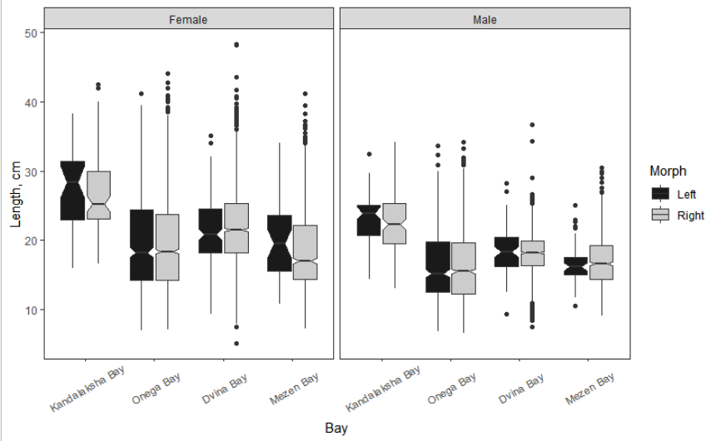**Fig. 2.** Description of the size composition for the left- and right-sided individuals of the European flounder from different bays of the White Sea. Non-overlapping triangular notches in the box plots indicate significantly different medians.

Logistic regression model M1 was constructed to analyse the relationship between the frequency of left-sided individuals and the length and sex of fish in the study samples. For this model, the Akaike Information Criterion (AIC) was 7457.0. Predictors “*Sex*”, “*Length*” and all interactions between terms have been removed from the model during the procedure of backward selection (for the final model AIC=7447.8). The parameters of the final model are shown in Table 1.

**Таблица 1.** Параметры финальной модели, описывающей связь вероятности встречи левосторонних особей с местом вылова речной камбалы в Белом море. За базовый уровень дискретного фактора “Bay” взят Kandalaksha Bay.

|  |  |  |  |  |
| --- | --- | --- | --- | --- |
| Term | Coefficient | SE | Z-statistic | p.value |
| (Intercept) | -0.765 | 0.121 | -6.32 | <0.001 |
| Bay(Onega Bay) | -0.565 | 0.127 | -4.46 | <0.001 |
| Bay(Dvina Bay) | -2.14 | 0.138 | -15.6 | <0.001 |
| Bay(Mezen Bay) | -2.60 | 0.168 | -15.5 | <0.001 |

**Table 1.** Parameters of the final model describing the relationship between collection site and the probability of encountering left-sided individuals in flounder populations from the White Sea. Kandalaksha Bay was selected as the baseline.

Результаты свидетельствуют, что статистически значимое воздействие на частоту реверсивных особей оказывает только место обитания популяции (фактор “*Bay*”), а влияния факторов “*Length*” и “*Sex*” (размера и пола) на соотношение морф не выявлено. The results indicate that a statistically significant effect on frequency of reversed individuals was determined by the location of the population (factor “*Bay*”). The factors “*Length*” и “*Sex*” did not influence the ratio of morphs. According to the final model, the frequencies of reversed individuals were highly different between flounder populations from studied bays (Fig. 3).

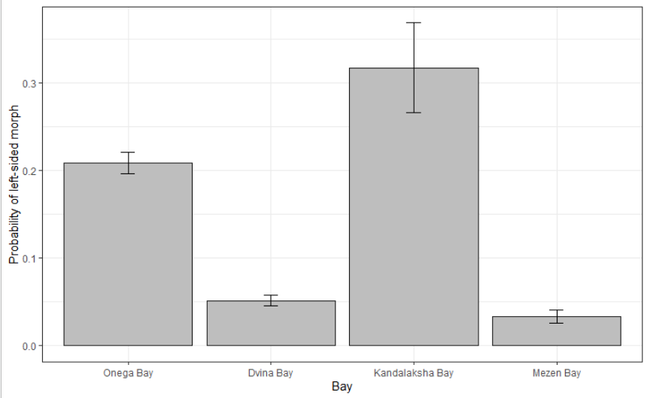

Fig. 3. Probability of encountering of left-sided morph in flounder populations from different bays, predicted by the Model 1. Wiskers represent 95% confidential interval.

For the sample from Onega Bay, the association between the frequency of reversed individuals with age and sex of flounder was analysed using logistic model М2. The parameters of the model are given in Table 2. These data show that there were no statistically significant effect of sex and age of fish on the proportion of morphs and significant interaction between those predictors. The frequency of left-sided individuals did not differ among fishes of various age groups (2-13 years) and between males and females.

**Таблица 2.** Параметры модели, описывающей связь вероятности встречи левосторонних особей с возрастом и полом у речной камбалы из Онежского залива Белого моря. За базовый уровень дискретного фактора “Sex” взята градация (level) “female”.

|  |  |  |  |  |
| --- | --- | --- | --- | --- |
| Term | Coefficient | SE | Z-statistic | p.value |
| (Intercept) | -1.36 | 0.157 | -8.67 | <0.001 |
| Age | -0.01 | 0.035 | -0.203 | 0.839 |
| Sex(male) | 0.11 | 0.226 | 0.480 | 0.632 |
| Age:Sex(male) | 0.01 | 0.053 | 0.136 | 0.891 |

**Table 2.** Parameters of the model describing the probability of encountering left-sided individuals as a function of the age and sex in flounder population from the Onega Bay. Level “female” was selected as the baseline of discrete factor “*Sex*”.

DISCUSSION

The results of this study confirm earlier observations (Semushin et al., 2015) that European flounders caught in the White Sea show no sex differences in the frequencies of left-sided individuals. Fornbacke et al. (2002) have also found no differences between sexes in proportion of morphs in adult European flounders off the coast of Sweden (Skagerrak Strait and the Baltic Sea) and similar results have been reported for the starry flounders of different sex (Townsend, 1937; Orcut, 1950). Our results, however, unlike these previously published observations, have also demonstrated a relative similarity of frequencies of reversed males and females within all size-age classes that had been included in the analysis.

The studies reporting changes in frequency of left- and right-sided individuals in the populations of the European flounder in connection with their size-age parameters are scarce and contradictory. In the flounders from coastal regions of Great Britain (Plymouth) and Germany, the proportion of left-sided fish in younger size-age classes was somewhat higher than among larger sexually mature individuals (Duncker, 1900). In author’s opinion, this indicates that mortality of left-sided flounders increases with age compared to the right-sided individuals. The statistical analysis of Duncker’s (1900) observations for the flounders from coastal waters of Germany conducted by Hubbs and Hubbs (1945) has revealed statistical significance of the observed differences between small and large flounders (χ2=8.18, p<0.05). In this respect, it should be noted that Duncker’s (1900, с.339-340) calculations relied in part on mixed material, which could have affected his results because of high population variation in this trait. In particular, the information on proportions of reversed individuals in sexually mature flounders from the coast of Germany has been derived from the sample that combined flounders from the western part of the Baltic Sea and the mouth of the Elbe River (North Sea basin). Sych (1930) based her analysis on a small sample of flounders from the Barents Sea and also compared the frequencies of left-sided individuals in the combined younger (1-4 years) and older (5-8 years) age classes. The differences between these two groups proved to be small and statistically insignificant (our calculations; χ2=0.82, р>0.05). Similar results reported by Sych (1930) for the White Sea flounders are not considered here, because they had been obtained from the material that combined samples from different bays. Fornbacke et al. (2002) have found that in the European flounders caught near the Swedish coast (Lysekil), the reversed individuals were significantly more common among the fry than among the adult fish (34% and 27%, respectively). The authors argued that a decrease in the proportion of left-sided individuals in adult fish is associated with higher mortality of the reversed flounders as compared with the right-sided individuals. Our results have shown that the frequency of left-sided individuals was not connected with size and age of fishes. These data were received by comparison of flounders in the size range of 5.1-48.3 cm and age of 2-13 years in local populations of the White Sea basin. It should be noted that the rates of axial growth for the left- and right-sided individuals were similar in both males and females. Fingerlings and yearlings were absent from the material included in our analysis, because no special collection was made at the sites that they inhabit.

The literature also contains information on frequency of left-sided individuals among the fish of different size/age for the starry flounder *P. stellatus*, a species closely related to the European flounder inhabiting coastal waters in the northern part of the Pacific Ocean. Hubbs and Hubbs (1945) have provided evidence for decreased survival of reversed individuals in flounders living near the Vancouver Island (British Columbia). According to their extensive observations, the proportion of the reversed morph in “largely young fish” caught near San Juan Islands, was significantly different from that in adult fish from Boundary Bay (52.2% and 48.4%, respectively). By contrast, the comparison of juvenile “largely young fish” and adult individuals of flounders captured in the same area (Boundary Bay) did not reveal any differences between them in the proportions of left- and right-sided fish (Hubbs and Hubbs, 1945). The authors suggested that the observed differences can be caused by interannual and seasonal variation in morph frequencies in the population. Orcut (1950) reported data on the proportion of left-sided individuals among the flounders of 3 age classes (0+; 1+; 2+ and older) from Monterey Bay (California). Statistically significant differences in frequency of reversed fish in these groups have been shown to occur only between fingerlings (0+) and yearlings (our calculations; χ2=5.12, р<0.05), with the latter showing higher frequencies. The largest/oldest individuals (>2+) in this study did not differ from small/young ones (0+ and 1+) in morph proportions. In the samples of adult flounders of commercial size (*SL*>31 cm) caught off the shores of British Columbia, the proportion of left- and right-sided fish was the same in the size classes studied (*SL*=32-68 cm) (Forrester, 1969). This has led the author to the conclusion that the two morphs did not differ in survival rates. Bergstrom (2007), who used small samples of flounders from the same region to compare two size classes of flounders (*SL*<20 cm and *SL*>20 cm), also concluded that younger and older size classes are similar in proportion of left-sided individuals. However, only small samples have been used and thus some size groups of fishes were absent in both studies. The proportions of the left- and right-sided fish in small samples are known to vary widely. For instance, the proportion of left-sided fish in 2 samples of *P. flesus* (n=200 individuals in each) taken from the same region of the Estonian coast (Mandjala, Saaremaa, Baltic Sea) in June and September 1942, was 22.5 and 35%, respectively (Mikelsaar, 1958).

The following important points can be drawn from the above discussion of the studies of the European and starry flounders. First, in most publications the trend was analysed based on comparison of only 2 portions of one sample consisting essentially of smaller and larger fish, rather than on the whole size range of the collected fish. Such analysis can distort possible changes in morph proportions occurring as the fish grows because of the subjective approach to identifying size classes under comparison. Second, the published data were contradictory: they demonstrated both increase and decrease in the proportion of the non-typical morph in larger/older individuals. It is possible that selective forces and the pressure they exert on survival of fry and adult fish of different morphs can be different in individual populations because of the differences in biotopic conditions of their habitats in various regions of the distribution range. As a result, the survival of left- and right-sided individuals at different stages of their life cycle can also differ in different populations of *P. flesus* and *P. stellatus*. In this respect, it appears reasonable to conduct a comparative analysis of changes in the proportion of morphs in the following 4 age categories of flounders: fingerlings (0+), sexually immature individuals (1-2-year old), recently matured individuals and adults.

The question about possible causes of high interpopulational variation of proportion of two phenotypes remains unanswered and still require additional investigations. It can be supposed that the individuals of the non-typical, left-sided, morph in some regions of the White Sea (Dvina Bay and Mezen Bay) show increased mortality during their first years (0+ and, possibly, 1+) of life, so their proportion in the populations is low. Such selective mortality in younger age classes can occur, in particular, because of the intra- or interspecific competition for food resources between young fish of the European flounder, Arctic flounder *Liopsetta glacialis* and common dab *Limanda limanda*, which share habitats in inlets and shallow coastal areas of the White Sea (Shatunovsky, Chestnova, 1970; Semushin, Sherstkov, 2012). Detected absence of changes in morph proportion with increasing age in the White Sea flounders might be related to the similarity of mortality between the left-sided and right-sided individuals of the same age. In our opinion, it could be explained, for example, by the ecological peculiarities of the European flounder. The flounder depart from the shore at the age of 2 years and later and then makes foraging forays into extensive shallow areas in the open sea, which is confirmed by our several-year-long observations and trawl catches in different parts of the White Sea. Changes in foraging locations, in addition to broadening of the dietary spectrum with age, probably lower the tension caused by intra- and interspecific competition for food of individuals of different morphs, which, in turn, can favour higher survival of the left-sided individuals. As a result, the mortality of the non-typical and typical morphs turn out to be very close at different stages (2-13 years) of flounder life cycle in various locations in the White Sea. Further study of survival of different morphs at fingerling and yearling stages, spatial distribution and the diet of both morphs in different biotopes will provide more insight into ecological mechanisms maintaining interpopulational variation in morph proportions in European flounder from the White Sea.

**ACKNOWLEDGEMENTS**

We are grateful to the staff of the Coastal Research Laboratory of the Polar branch of FSBI “VNIRO” for their help in collecting data during expeditions. This work was carried out as part of the State Task of the Zoological Institute RAS (state registration number no. 1021051402749-2).

ЛИТЕРАТУРА

Christensen J. M. Burning otoliths, a technique for age determination of soles and other fish. J. Cons. Perm. int. Explor. 1964. Mer. 29, 73–81.

Chilton D. E., Beamish R. J. Age determination methods for fishes studied by the groundfish program at the Pacific Biological Station // Canadian Special Publication of Fisheries and Aquatic Sciences. 1982. N 60. 102 p.

Andriashev AP (1954) Fishes of the northern seas of the USSR. Izd Akad Nauk SSSR, Moscow,

Leningrad [In Russian]

Andriashev, A.P., *Ryby severnykh morei SSSR* (Fishes of the Northern Seas of the USSR),

Moscow: Akad. Nauk SSSR, 1954.

Altukhov К А, Мikhailovskaya А А, Mukhomediyarov FB, Nadezhin VM, Novikov PI,

Palenichko ZG (1958) Fishes of the White Sea. Gosudarstvennoe izdatelstvo Karelskoy ASSR, Petrozavodsk, USSR [In Russian]

Berg LS (1949) Freshwater fishes of the U.S.S.R. and adjacent countries. Nauka, Moscow-

Leningrad [In Russian]

Bergstrom C. A. 2007. Morphological evidence of correlational selection and ecological

segregation between dextral and sinistral forms in a polymorphic flatfish, *Platichthys stellatus*. *Journal of Evolutionary Biology*, **20**: 1104–1114. <https://doi.org/10.1111/j.1420-9101.2006.01290>

Brey T (2001) Population dynamics in benthic invertebrates. A virtual handbook. Version 01.2.

<http://www.thomas-brey.de/science/virtualhandbook>

Duncker G (1900) Variation und Asymmetrie bei *Pleuronectes flesus* L. Wiss Meereunters 3:

333-406

Fornbacke M, Gombrii M, Lundberg A (2002) Sidedness frequencies in the flounder *Platichthys*

*flesus* (Pleuronectiformes) along a biogeographical cline. Sarsia 87: 392–395

Forrester C R 1969 Sinistrality in *Platichthys stellatus* off British Columbia. J Fish Res Bd Can 26: 191–196

Forrester C.R. 1969. Sinistrality in Platichthys stellatus off British Columbia. Journal of the

Fisheries Research Board of Canada, 26: 191–196. <https://doi.org/10.1139/f69-023>

Hubbs C L & Hubbs L C (1945). Bilateral asymmetry and bilateral variation in fishes.

Papers of the Michigan Academy of Science, Arts and Letters 30, 229–310

Mikelsaar N (1958) Method of equalized scales. In: Hydrobiological investigations. Izd Akad

Nauk ESSR, Tartu, USSR, Issue 1, pp 286-312 [In Russian]

Mikelsaar N. 1958. Method of equalized scales. Gidrobiologicheskie issledovaniya (Tartu:

Izdatelstvo Akademii Nauk ESSR), 1: 286–312. [In Russian].

Orcutt H G (1950) The life history of the starry flounder *Platichthys stellatus* (Pallаs). Calif. Fish

Game Fish Bull. 78: 1–64

Quinn, G. P., & Keough, M. J. (2002). Experimental design and data analysis for biologists. Cambridge university press.

Russo T, Pulcini D, Costantini D et al (2012) “Right” or “wrong”? Insights into the ecology of

sidedness in European flounder, *Platichthys flesus*. J Morphol 273: 337–346

[https://doi.org/10](https://doi.org/10.1002/jmor.11027)[.1002/jmor.11027](https://doi.org/10.1002/jmor.11027)

R Core Team. 2020. R: A language and environment for statistical computing. R Foundation for

Statistical Computing, Vienna, Austria. <http://www.r-project.org/index.html>

Semushin A V and Sherstkov A S (2012) Pleuronectidae fishes. In: Biological resources of the White Sea: investigations and exploitation (ed. Pugachev O N). Explorations of fauna of the seas 69 (77). ZIN RAN, Saint-Petersburg, pp.205-221

Pleuronectidae, in Issledovanie fauny morei. Biologicheskie resursy Belogo morya: izuchenie i ispol’zovanie (Study of Marine Fauna. Biological Resources of the White Sea: Study and Use), *St. Petersburg: Zool. Inst., Ross. Akad. Nauk*, 2012, vol. 69 (77), pp. 205–221.

Semushin AV, Fuks GV, Shilova NA (2015) Flatfishes of the White Sea: New data on the

biology of the Arctic flounder *Liopsetta glacialis*, European flounder *Platichthys flesus*,

and Сommon dab *Limanda limanda*. J Ichthyol 55: 527-539. <https://doi.org/10.1134/S0032945215030121>

Shatunovsky MI and Chestnova LG (1970) Some biological characteristics of the flounder from

the Kandalaksha Bay in the White Sea. Rep White Sea biol station State Univ Moscow 3:

166-188 [In Russian]

Shatunovsky MI and Chestnova LG 1970. Some biological characteristics of the flounder

from the Kandalaksha Bay in the White Sea. Trudy Belomorskoy Biologicheskoy stantsii Moskovskogo Universiteta, 3: 166–188 [In Russian].

Sych NS (1930) *Pleuronectes flesus* of the Barents and White Seas. Trudy Gos Nauch Issl Inst

Rybn Khoz 5: 89-116 [In Russian]

Townsend L D 1937 Geographical variation and correlation in Pacific flounders. Copeia 2: 92–103

Zuur A., Ieno E., Walker N., Saveliev A. and Smith G. 2009. Mixed effects models and

extensions in ecology with R. Spring Science and Business Media, New York, NY, 580 p. <https://doi.org/10.1007/978-0-387-87458-6>

Fuks GV 2015. Method of determining the age of the river flounder *Platichthys fles*us in the otoliths in the north-western regions of the Russian arctic seas. Educatio X(17): 27-30

**FIGURE CAPTIONS**

**Fig**.**1**.

**TABLES**

**Table 1**.

|  |  |  |  |  |
| --- | --- | --- | --- | --- |
| **Term** | **Coefficient** | **SE** | **Z-statistic** | **p.value** |
| (Intercept) | -1.367 | 0.092 | -14.805 | <0.001 |
| Length | 0.017 | 0.005 | 3.726 | <0.001 |
| BayDvina Bay | -1.898 | 0.074 | -25.632 | <0.001 |
| BayKandalaksha Bay | 0.184 | 0.128 | 1.437 | 0.150 |
| BayMezen Bay | -2.306 | 0.121 | -19.005 | <0.001 |